Problem 4 (I'm using ER Assistant Software for creating the diagrams)

Given ER Diagram:

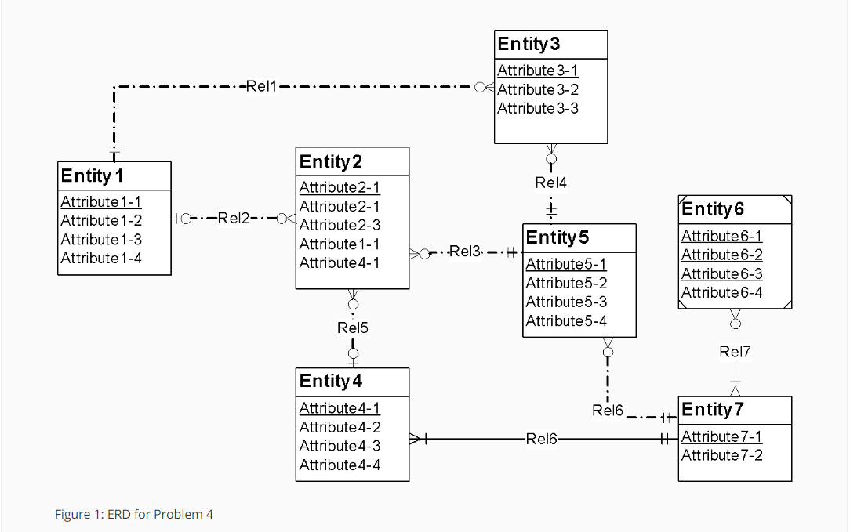

Above ER Diagram has the following errors:

1. *Identification Dependency Cardinality Rule Violation* (At **Rel7). Cardinality of Weak Entity should be (1,1)**
2. *Redundant FK(Foreign Key) Rule Violation*(At **Rel2**, **Entity 2 is having Attribute1-1 which is primary key of Entity 1.**
3. *Redundant FK(Foreign Key) Rule Violation*(At **Rel5**, **Entity 2 is having Attribute4-1 which is primary key of Entity 4.**
4. *Identifying Relationship Rule Violation.* ***The relationship between Entity4 and Entity7 is given identifying but none of them is weak entity.***

Attribute Name Rule Violation:**Entity 2 is having 2 attributes with same name Attribute2-1.**

The ER Diagram with errors is shown below:

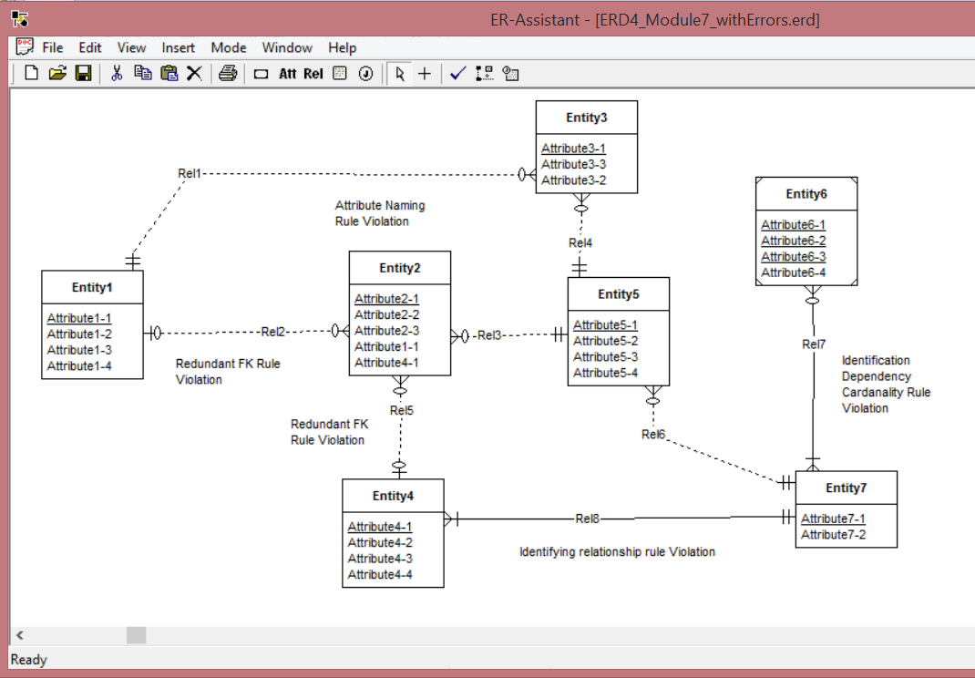

The errors can be resolved by the following modifications:

1. Resolution of *Identification Dependency Cardinality Rule*  (At ***Rel7): Cardinality of ‘Rel7’ near Entity7 is made to be (min,max) = (1,1)***
2. Resolution of *Redundant FK(Foreign Key) Rule (At* ***Rel2): Remove the redundant foreign key (Entity2.Attribute1-1)***
3. Resolution of *Redundant FK(Foreign Key) Rule(At* ***Rel5): Remove the redundant foreign key (Entity2.Attribute4-1)***
4. Resolution of *Identifying Relationship Rule(Relationship between* ***Entity4 and Entity7****):* ***Make this relationship non-identifying.***
5. Resolution to Attribute Name Rule (in Entity2): ***Rename the Attribute2-1 which is not primary key to Attribute2-2.***

Corrected Diagram:

